**2020 4 Wall State Singles Tournament Recap**

**March 4-5, 2022**

**Detroit Athletic Club**

We had a strong turnout for the 2022 State 4 Wall Singles. The results are below:

Open Division

The Open Division was the largest division with 10 teams. We split the division into two pools of five with the round robin winners playing in the final. 2 matches were played Friday night and two Saturday. Matches were best of 3 -15 point games. The winners of each pool played a final.

 

In pool A, the theme was tie breaker. Alex May, a great new addition to Michigan Handball, brought his experience from Illinois and teamed up with Bob Balch. Bob, also playing in the 65s, made some key shots late in the tie breaker to support a hot partner and they edged Alex Bieri and Rick Leonard. Bieri/Leonard pulled out a tie breaker from an up-and-coming team of Greg Scanlan and Shawn Walker.

Billy Sidebottom Jr. and Ben Hall pushed the eventual pool winners to a tie breaker giving Pat Oliver and Vincent Yam their only game loss in pool play. Pat’s steady play on the left and Vince’s cut offs, digs and re-kills were too much for everyone. Vince – an experienced one waller from New York is quickly learning the 4 wall game.

In pool B, the Veterans Mike Fagan and Pete Hanover battled the reigning 4 wall singles champion Ryan Inman and Tony Girgenti to a tie breaker Friday night. The steady play and mental focus of the veterans proved to be too much.

Fagan/Hanover also won a tie breaker Saturday beating Nick Lowe and his son Cameron. Cameron is a freshman at Lake Forest and playing on the college team. His game jumped immensely with the stellar coaching and practice. Lowe and Lowe jumped on Pete Brown and his partner Scott Jonna in the first match Friday night.

Brown and Jonna rebounded winning the pool with a 2 game win over Fagan and Hanover. There were numerous tie breaker scenarios in play but the veteran team played one to many tie breakers and seemed to hit a mental wall. Pete Brown got his serve and kill game going. Jonna was steady on the right with power passes and good returns.

The final was too much Oliver and Yam as they won in 2 games. Brown and Jonna got things going more in game two keeping it tighter. But a 15-9 game two was sealed as Vince Yam dove and re-killed a low kill shot from Brown.

Vincent (left), Pat (right)

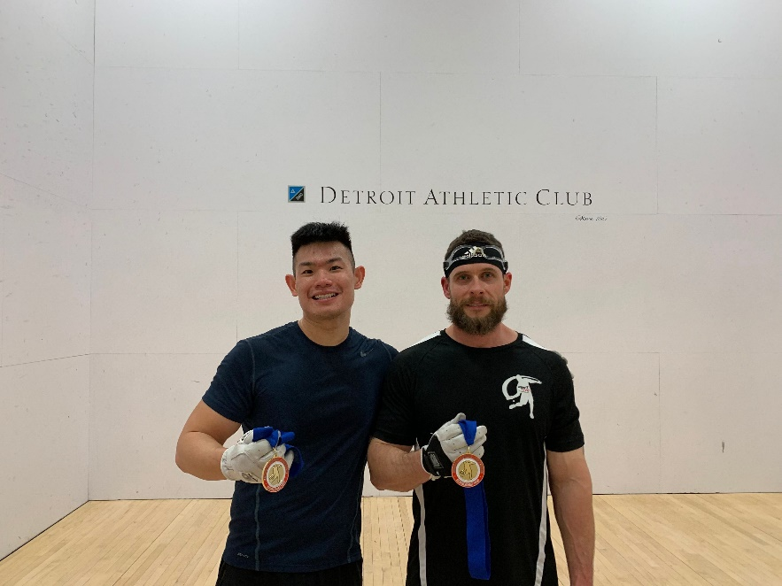

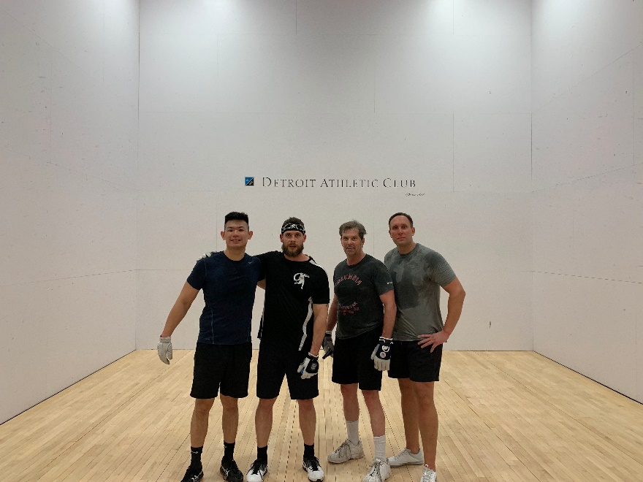

65s Division



Bob Balch teamed up Jack Digiovanni to win the 65s division. They defeated Larry Price and Ed Kulka Friday night. Price and Kulka had the 3rd seed challenge of playing their second match on the same night and lost to Stuart Shevin and Chuck Ferro.

With Jacks steady left-handed play and Bob’s great power and front court coverage, they were too much for Shevin/Ferro and won in two games (12, 15).

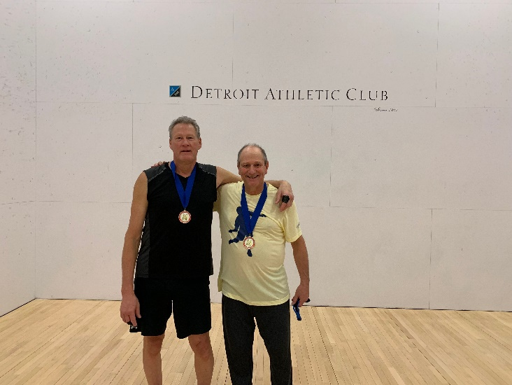

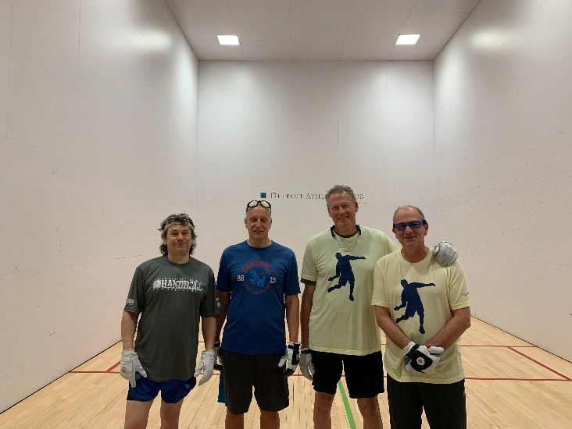

70s Division



We had 4 teams for a round robin in the 70s division. The top two seeds of Rick Graham/Bill Cleary and Eddie Green/Kevin McGivern met in the final - both had 2-0 records.

Rick Graham demonstrated the most import skill in Doubles Handball – pick a good partner. Former MHA President Bill Cleary came in from Atlanta to play a solid right court. All 4 players in the final showed impressive power in the 70s age group.

Graham and Cleary successfully defended their 70s title in two games.

